Training Course
on
Commercial Farm Management

15 November – 19 November 2020

Course Completion Report

National Agriculture Training Academy (NATA)
Ministry of Agriculture
Gazipur-1701
www.nata.gov.bd

Course Management Team

Course Advisor & :  Course Director | Dr. Md. Abu Sayeed Miah  Director General (In-charge)  NATA, Gazipur  Phone: 02-49272104
Course Coordinator : | Dr. Abdul Awal Miah  Deputy Director (Agronomy)  NATA, Gazipur  Mob.: 01628862576
Asst. Course Coordinator: | Md. Aklimuzzaman  Senior Assistant Director  (Pulse & Oil Crops)  NATA, Gazipur  Mob.: 01719303797  &  Sumaya Sharmin  Publication Officer  NATA, Gazipur  Mob.: 01738135204

Contents

Sl. No. | Subject | Page
1 | Introduction | 4
2 | Course information at a glance | 5
3 | Course content | 6
4 | List of Resource Personnel | 7
5 | List of Participants | 8-9
6 | Training schedule | 10-11
7 | Pre & post evaluation of the Trainees | 12-13
8 | Speaker Evaluation by the Trainees | 14
9 | Training Course Evaluation by the Trainees | 15-16
10 | Pictorial View of Training Activities | 17-19

Introduction

Dramatic changes are taking place in farming worldwide due to globalization, liberalization and rapid urbanization. As a result of this change, the small holder farm structure is rapidly transforming into a commercial farm. Such farm is being the integral part of industrial economy of Bangladesh which is controlled by the entrepreneurs instead of subsidy-dependent subsistent farmers. Therefore, appropriate management of a commercial farm is necessary for the farm owner/entrepreneurs to exploit maximum output through proper utilization of land and natural resources.
Farm management is the science and art of optimizing the use of resources in the farm component of farm-households. As technical know-how of the farmers is not enough, commercial farm management know-how and skills is recognized as important for farmers to effectively respond to present day farming challenges. Agricultural officers, researchers and farm managers are also called upon to provide services for efficient and effective farm management. Keeping this in mind and to enhance quality of better services of the agricultural officers/researchers in general, this knowledge sharing training course on Commercial Farm Management has been designed to enable them to work at the strategic level of management and leadership in the commercial environment of modern farming and agribusiness.

Course objectives

- organize for developing and managing efficiently a commercial farms in agriculture;
- explain special practices for attaining higher productivity and profitability;
- perform economic analysis economically of agro-based commercial enterprises;
- advise on post-harvest technology and value addition activities for quality produces;
- enhance linkage with marketing channels for farm produces; and
- Contribute effectively in developing entrepreneurships in farming community.

Course Information at a Glance

Duration of the Course | : | 5 days (15 November-19 November, 2020)
Duration of each Session | : | 60 minutes
Participants | : | Officers (9th Grade to Above) of different organizations under ministry of Agriculture
No. of total participants | : | 30 (Male 32, Female 08)
No. of Cadre officer | : | 14 (Male 10, Female 04)
No. of Non - Cadre officer | : | 16 (Male 12, Female 04)
No. of Resource Personnel | : | 17
No. of Session | : | 25

Course Content

Sl. No. | Content
 | Module - 1: Farm development and management
1. | Lesson 1: Agricultural transformation – the changing scenario of agricultural landscape
2. | Lesson 2: Farm development: Layout, management, records and crop selection
3. | Lesson 3: Farm planning, budgeting, personnel and risk management in a farm
4. | Lesson 4: Mechanization and profitable use of agricultural implements in a farm
 | Module - 2: Economic management of important crops
5. | Lesson 1: Economic management of important commercially grown vegetables (tomato, brinjal, cucumber, bottle gourd, bitter gourd, country bean, cauliflower, etc.)
6. | Lesson 2: Economic management of important commercially grown exotic vegetables (broccoli, squash, carrot, salad crops, capsicum, etc.)
7. | Lesson 3: Economic management of important commercially grown fruits (mango, guava, papaya, jujube, lemon, banana, pineapple, water melon, etc.)
8. | Lesson 4: Economic management of important commercially grown exotic fruits (dragon fruit, multa, orange, straw-berry, avocado, rambutan, date palm, etc.)
9. | Lesson 5: Economic management of important ornamental flowers (lilium, gladiolus, gerbera, rose, tube rose, etc.)
10. | Lesson 6: Economic management of important commercially grown field crops and seed production business
 | Module - 3: Profitability of special enterprises
11. | Lesson 1: Economic management of nursery enterprise
12. | Lesson 2: Post-harvest technology and profitable management of farm products
13. | Lesson 3: Profitability analysis in roof top gardening/agriculture
14. | Lesson 4: Profitability analysis in mushroom cultivation and processing
 | Module - 4: Economic analysis in agriculture
15. | Lesson 1: Introduction to economic terms, data collection and data processing
16. | Lesson 2: Economic analysis of some agro-based commercial enterprises
17. | Lesson 3: Economics of production and marketing cost of major crops (with exercise)
 | Module - 5: Supply & value chain management and marketing
18. | Lesson 1: Concept & importance of Good Agricultural Practices (GAP), structure of Bangladesh GAP and global GAP
19. | Lesson 2: Supply and value chain management of different agro-products
20. | Lesson 3: Export potential and criteria & procedure for export of horticultural crops
21. | Lesson 4: Marketing system of farm products: Principles, constrains and opportunities
 | Module - 6: Entrepreneurship and business/project plan
22. | Lesson 1: Concept on development and scope of entrepreneurship in agriculture
23. | Lesson 2: Introduction to investment profile using RuralInvest tool kit (software)
24. | Lesson 3: Exercise on inserting field data into the RuralInvest tool
25. | Lesson 4: Exercise on case studies for preparing business plans using RuralInvest tool
26. | Lesson 5: Group works and presentation on preparing business plans/agriculture project using profile
27. | Assignment: Designing, planning and budgeting for a integrated commercial farm

List of Resource Personnel

Sl. No. | Name of speaker and  Designation | Address | Mobile &  e-mail
1 | Dr. M. Sadrul Amin  Rtd Dean & Professor | HSTU, Dinajpur | 01988802253  sadrulamin47@gmail.com
2 | Dr. Md. Shariful Islam  DD (PRL) | DAE, Dhaka | 01743051115  kbdshariful@gmail.com
3 | Dr. Babul Chandra Sarker  Chief Scientific Officer | Pomology Division, BARI, Gazipur | 01716009319  bsarker_64@yahoo.com
4 | Dr. Md. Durrul Huda  Chief Scientific Officer | FMHT Division,  BRRI, Gazipur | 01719783558  mdurrulh@hotmail.com
5 | Dr. M.A Goffar  Principal Scientific Officer | Vegetable Division, BARI, Gazipur | 01552442512  mgoffar@yahoo.com
6 | Dr. Farjana Nasrin Khan  Principal Scientific Officer | Floriculture Division, BARI, Gazipur | 01910047191  khan_farjana@yahoo.com
7 | Dr. Md. Mahmud Hasan  DD (Horticulture) | NATA, Gazipur | 01817066613  mahmudhassandae@gmail.com
8 | Dr. Md. Jamal Uddin  DD (Plant Pathology) | NATA, Gazipur | 01712272859  jamaldae@yahoo.com
9 | Dr. M. A. Monayem Miah  Principal Scientific Officer | Agriculture Economics Division, BARI, Gazipur | 01757739542  monayem09@yahoo.com
10 | Dr. Nirod Chandra Sarker  Deputy Director | Mashroom Devt. Institute, Savar, Dhaka | 01552408152  nirod_chandra@yahoo.com
11 | Dr. Abdul Awal Miah  DD (Agronomy) | NATA, Gazipur | 01718893734  awaldae1989@gmail.com
12 | Dr. Md. Mahbub Alam  Producer Organization Mobilization Specialist | Project Management Unit, NATP-2 Project, BARC, Dhaka | 01753488788  mahbub@consultant.com
13 | Dr. Md. Nazim Uddin  Senior Scientific Officer | HRC, BARI, Gazipur | 01715087383  nazim.68@gmail.com
14 | Md. Mamunur Reza  Assistant Director | Hort. Dev. Centre, BADC, Gazipur | 01911152367  rezamm.bd@gmail.com
15 | Md. Taherul Islam,  Project Director | Urban Agriculture. Prod. Support Project, DAE | 01712685377  01533330501
16 | Dr. Taslima Ayesha Aktar Nasrin  Senior Scientific Officer | PHTS, HRC, BARI | 01751904470  taanasrin@gmail.com
17 | Md. Shahinul Islam  Sr. AD (Field Crop Pest) | NATA, Gazipur | 01745997741  shahinul_bsmrau02@yahoo.com

List of Participants

SL. | Name | Designation & Posting Place and Organization
 | MD. MOSTOFA MAHBUB | Senior Scientific Officer  Agronomy Division, BRRI, Gazipur
 | MD. AYUB ALI | Farm Superintendent  Farm Management Division, BRRI, Gazipur
 | NAYEMA AKTAR | Farm Manager, BINA, Mymensingh
 | JANNATUL FERDOUS MOONMOON | Farm Manager, BINA, Jamalpur
 | KISHOR KUMAR SAHA | Assistant Director-Training  Regional Training Center  DAM, Narshingdi
 | DR. M. M. ABED ALI | Senior Scientific Officer  Cotton Research Farm, CDB, Jagodishpur, Chowgacha, Jashore
 | GOLAM SAGIR AHAMMAD | Scientific Officer  BIRTAN, Dhaka
 | ATIYA SHARMIN MITU | Scientific Officer  Regional Sugarcrop Research Station, BSRI, Gazipur
 | MD. SHAWQUAT ALI KHAN | Senior Scientific Officer  Training and Communication Wing, BARI, Gazipur
 | MD. MAHBUBAR RAHMAN SALIM | Senior Scientific Officer  Olericulture Division, BARI, Gazipur
 | SHYAMAL BRAHMA | Senior Scientific Officer  Regional Spices Research Center, BARI, Gazipur
 | MOHAMMAD AYUB HOSSAIN KHAN | Scientific Officer  Regional Agriculture research Station, BARI, Cumilla
 | MD. ZEHAD | Scientific Officer, Jute Agriculture Experimental Station, Jagir, Manikganj
 | ASIF IQBAL SAKI | Deputy Director  Horticulture Development Center, BADC, Muktagacha, Mymensingh
 | BIPLAB KUMAR MOHANTA | Senior Assistant Director  Pulse and Oil Seed Contract Growers Zone , BADC, Pabna
 | FARIDA AKTER | Assistant Manager  Jute Seed Division, BADC, Krishi Bhaban, Dhaka
 | MD. ALI HOSSAIN | Assistant Director  Contract Growers Zone, BADC, Faridpur
 | MOHAMMED ABDUL HYE | Additional Deputy Director (Crop)  DAE, Narayanganj
 | SK. ABDULLAH WAHED | Upazila Agriculture Officer  Hathazari, Chattogram
 | SHEULI MAZUMDER | Agriculture Extension Officer  Rupsa, Khulna
 | AMIT BAGCHI | Agriculture Extension Officer  Maheshpur, Jhenaidah
 | MD. MONIRUZZAMAN | Agriculture Extension Officer  Sapahar, Naogaon
 | SAJIB SARKER | Agriculture Extension Officer  Kanaighat, Sylhet
 | MD. ABDUL HANNAN | Agriculture Extension Officer  Dinajpur Sadar, Dinajpur
 | HUSNEYARA KHATUN | Agriculture Extension Officer  Sadarpur, Faridpur
 | ABDULLAH-AL-MAHMUDUN-NUR | Agriculture Extension Officer  Netrokona Sadar, Netrokona
 | KUNTALA GHOSH | Agriculture Extension Officer  Pabna Sadar, Pabna
 | RAZIYA TARAFDER | Agriculture Extension Officer  Gaibandha Sadar, Gaibandha
 | MD. RABIUL AOWAL | Agricultural Engineer  DAE, Patuakhali
 | AMINUR RASHID | Additional Deputy Director (PP)  DAE, Narayanganj
Training Schedule

Date: 15/11/2020 (Day-1) Day: Sunday
Time | Topic/Session | Speaker/Facilitator
09:00 - 09:15 | Registration | Sumaya Sharmin, Pub. Officer, NATA
09:15 - 09:35 | Pre-evaluation test, training expectation and norms | Md. Aklimuzzaman, Sr.AD, NATA
09:35 - 09:45 | Inaugural ceremony | DG/Director/Faculty members
09:50 - 10:50 | Agricultural transformation – moving from subsistence to commercial agricultural | Dr. M. Sadrul Amin, Rtd Dean, HSTU, Dinajpur
10:50 - 11:10 | Tea Break
11:10 - 12:10 | Farm planning, budgeting, personnel and risk management in a farm | Do
12:15 - 01:15 | Farm development: Layout, management, records and crop selection | Dr. Md. Shariful Islam, DD (PRL), DAE, Dhaka
01:15 - 02:30 | Prayer & Lunch
02:30 - 03:30 | Economic management of nursery enterprise | Dr. Md. Mahmud Hasan  DD (Horticulture), NATA
03:30 - 04:45 | Concept & importance of Good Agricultural Practices (GAP), structure of Bangladesh GAP and global GAP | Do

Date: 16/11/2020 (Day-2) Day: Monday
Time | Topic/Session | Speaker/Facilitator
09:15 - 09:35 | Review of previous day | Md. Aklimuzzaman, Sr.AD, NATA
09:35 - 10:35 | Mechanization and profitable use of different agricultural implements of a farm | Dr. Md. Durrul Huda  CSO, FMHT Division, BRRI
10:35- 11:00 | Tea Break
11:00 - 12:00 | Economic management of important commercially grown vegetables | Dr. M.A. Goffar, PSO  Vegetable Division, BARI, Gazipur
12:10 - 01:10 | Economic management of important ornamental flowers (lilium, gladiolus, gerbera, rose, tube rose, etc.) | Dr. Farjana Nasrin Khan, PSO, Floriculture Division, BARI, Gazipur
01:10 - 02:20 | Prayer & Lunch
02:20 - 03:20 | Economic management of important commercially grown fruits | Dr. Babul Chandra Sarker, CSO &  Head, Pomology Div., BARI, Gazipur
03:20 - 04:20 | Economic management of important commercially grown exotic fruits and ornamental flowers | Do
04:20 - 05:10 | Social Safety Net | Dr. Md. Jamal Uddin,  DD (Plant pathology), NATA

Date: 17/11/2020 (Day-3) Day: Tuesday
Time | Topic/Session | Speaker/Facilitator
09:15 - 09:35 | Review of previous day | Sumaya Sharmin, Pub. Officer, NATA
09:35 - 10:35 | Introduction to economic terms, data collection and data processing | Dr. M. A. Monayem Miah, PSO, Agil. Economics Div., BARI, Gazipur
10:35- 11:00 | Tea Break
11:00 - 12:00 | Economic analysis of some agro-based commercial enterprises | Do
12:10 - 01:10 | Economics of production and marketing cost of major crops (with exercise) | Do
01:10 - 02:30 | Prayer & Lunch
02:30 - 03:40 | Profitability analysis in mushroom cultivation and processing | Dr. Nirod Chandra Sarker, DD  Mashroom Devt. Institute, Savar
03:40 - 04:50 | Economic management of important commercially grown field crops and seed production business | Dr. Abdul Awal Miah  DD (Agronomy), NATA

Date: 18/11/2020 (Day-4) Day: Wednesday
Time | Topic/Session | Speaker/Facilitator
09:15 - 09:35 | Review of previous day | Md. Aklimuzzaman, Sr.AD, NATA
09:35 - 10:35 | Supply and value chain management of different agro-products | Dr. Md. Mahbub Alam  Producer Organization Mobil. Specialist, PMU, NATP-2, BARC
10:35- 11:00 | Tea Break
11:00 - 12:00 | Marketing system of farm products: Principles, constrains and opportunities | Do
12:10 - 01:10 | Potentials of organic and safe production as commercial means | Dr. Md. Nazim Uddin, SSO,  HRC, BARI, Gazipur
01:10 - 02:20 | Prayer & Lunch
02:20 - 03:20 | Poly/tunnel house and green house cultivation technology | Md. Mamunur Reza, Assistant Direc.,  HDC, BADC, Gazipur
03:20 - 04:20 | Profitability analysis in rooftop gardening/agriculture | Md. Taherul Islam, PD  Urban Ag. Prod. Support Project, DAE
04:20 - 05:10 | SDGs (Sustainable Development Goals) | Dr. Md. Jamal Uddin,  DD (Plant pathology), NATA

Date: 19/11/2020 (Day-5) Day: Thursday
Time | Topic/Session | Speaker/Facilitator
08:30 - 08:40 | Review of previous day | Sumaya Sharmin, Pub. Officer, NATA
08:40 - 09:40 | Post-harvest technology and profitable management of farm products | Dr. Taslima Ayesha Aktar Nasrin  SSO, PHTS, HRC, BARI
09:40 - 10:40 | Export potential and criteria & procedure for export of horticultural crops | Do
10:40 - 11:00 | Tea Break
11:00 - 12:00 | Introduction to investment profile using Rural Invest tool kit (software) | Md. Shahinul Islam  Sr.AD (Field Crop Pest), NATA
12:00 - 01:00 | Exercise on inserting field data into the Rural Invest tool | Do
01:00 - 01:25 | Post-evaluation and course evaluation | Course Coordinator and  Asst. Course Coordinator
01:25 - 02:30 | Prayer & Lunch
02:30 - 03:30 | Awarding certificate and closing | DG/Directors/Faculty Members
* This schedule and speaker are subjected to change.

Pre and Post Evaluation of the Trainees

Total Marks: 40
SL No. | Name | Designation and Address | Obtained Marks
 |  |  | Pre Training | Post Training
1 | MD. MOSTOFA MAHBUB | Senior Scientific Officer  Agronomy Division, BRRI, Gazipur | 11.5 | 31.5
2 | MD. AYUB ALI | Farm Superintendent  Farm Management Division, BRRI, Gazipur | 20 | 25.5
3 | NAYEMA AKTAR | Farm Manager, BINA, Mymensingh | 30.5 | 35
4 | JANNATUL FERDOUS MOONMOON | Farm Manager, BINA, Jamalpur | 27 | 32.5
5 | KISHOR KUMAR SAHA | Assistant Director-Training  Regional Training Center  DAM, Narshingdi | 3.5 | 32
6 | DR. M. M. ABED ALI | Senior Scientific Officer  Cotton Research Farm, CDB, Jagodishpur, Chowgacha, Jashore | 25.5 | 35.5
7 | GOLAM SAGIR AHAMMAD | Scientific Officer  BIRTAN, Dhaka | 29 | 34
8 | ATIYA SHARMIN MITU | Scientific Officer  Regional Sugarcrop Research Station, BSRI, Gazipur | 2.5 | 32.5
9 | MD. SHAWQUAT ALI KHAN | Senior Scientific Officer  Training and Communication Wing, BARI, Gazipur | 25 | 37
10 | MD. MAHBUBAR RAHMAN SALIM | Senior Scientific Officer  Olericulture Division, BARI, Gazipur | 25 | 38
11 | SHYAMAL BRAHMA | Senior Scientific Officer  Regional Spices Research Center, BARI, Gazipur | 23 | 36.5
12 | MOHAMMAD AYUB HOSSAIN KHAN | Scientific Officer  Regional Agriculture research Station, BARI, Cumilla | 27 | 33.5
13 | MD. ZEHAD | Scientific Officer, Jute Agriculture Experimental Station, Jagir, Manikganj | 21 | 36
14 | ASIF IQBAL SAKI | Deputy Director  Horticulture Development Center, BADC, Muktagacha, Mymensingh | 34 | 35.5
15 | BIPLAB KUMAR MOHANTA | Senior Assistant Director  Pulse and Oil Seed Contract Growers Zone , BADC, Pabna | 27 | 37
16 | FARIDA AKTER | Assistant Manager  Jute Seed Division, BADC, Krishi Bhaban, Dhaka | 21.5 | 35.5
17 | MD. ALI HOSSAIN | Assistant Director  Contract Growers Zone, BADC, Faridpur | 23 | 33.5
18 | MOHAMMED ABDUL HYE | Additional Deputy Director (Crop)  DAE, Narayanganj | 20 | 30
19 | SK. ABDULLAH WAHED | Upazila Agriculture Officer  Hathazari, Chattogram | 32 | 33
20 | SHEULI MAZUMDER | Agriculture Extension Officer  Rupsa, Khulna | 25 | 32.5
21 | AMIT BAGCHI | Agriculture Extension Officer  Maheshpur, Jhenaidah | 19 | 34
22 | MD. MONIRUZZAMAN | Agriculture Extension Officer  Sapahar, Naogaon | 30 | 32.5
23 | SAJIB SARKER | Agriculture Extension Officer  Kanaighat, Sylhet | 15.5 | 36.5
24 | MD. ABDUL HANNAN | Agriculture Extension Officer  Dinajpur Sadar, Dinajpur | 31 | 36.5
25 | HUSNEYARA KHATUN | Agriculture Extension Officer  Sadarpur, Faridpur | 30 | 34
26 | ABDULLAH-AL-MAHMUDUN-NUR | Agriculture Extension Officer  Netrokona Sadar, Netrokona | 21.5 | 38
27 | KUNTALA GHOSH | Agriculture Extension Officer  Pabna Sadar, Pabna | 28 | 38
28 | RAZIYA TARAFDER | Agriculture Extension Officer  Gaibandha Sadar, Gaibandha | 19.5 | 34.5
29 | MD. RABIUL AOWAL | Agricultural Engineer  DAE, Patuakhali | 23.5 | 37.5
30 | AMINUR RASHID | Additional Deputy Director (PP)  DAE, Narayanganj | 19 | 32.5

Speaker Evaluation by the Trainees
Date | Topic | Speaker | Obtained Marks (Ave.)
15/11/2020 | Agricultural transformation – moving from subsistence to commercial agricultural | Dr. M. Sadrul Amin, Rtd Dean, HSTU, Dinajpur | 4.5
 | Farm planning, budgeting, personnel and risk management in a farm |  | 4.0
 | Farm development: Layout, management, records and crop selection | Dr. Md. Shariful Islam, DD (PRL), DAE, Dhaka | 5.0
 | Economic management of nursery enterprise | Dr. Md. Mahmud Hasan  DD (Horticulture), NATA | 5
 | Concept & importance of Good Agricultural Practices (GAP), structure of Bangladesh GAP and global GAP |  | 5
16/11/2020 | Mechanization and profitable use of different agricultural implements of a farm | Dr. Md. Durrul Huda  CSO, FMHT Division, BRRI | 5.5
 | Economic management of important commercially grown vegetables | Dr. M.A. Goffar, PSO  Vegetable Division, BARI | 4.5
 | Economic management of important ornamental flowers (lilium, gladiolus, gerbera, rose, tube rose, etc.) | Dr. Farjana Nasrin Khan, PSO, Floriculture Division, BARI | 5.5
 | Economic management of important commercially grown fruits | Dr. Babul Chandra Sarker, CSO &  Head, Pomology Div., BARI | 5.5
 | Economic management of important commercially grown exotic fruits and ornamental flowers |  | 5.5
 | Social Safety Net | Dr. Md. Jamal Uddin,  DD (Plant pathology), NATA | 5.5
17/11/2020 | Introduction to economic terms, data collection and data processing | Dr. M. A. Monayem Miah, PSO, Agil. Economics Div., BARI | 5
 | Economic analysis of some agro-based commercial enterprises |  | 5
 | Economics of production and marketing cost of major crops (with exercise) |  | 5
 | Profitability analysis in mushroom cultivation and processing | Dr. Nirod Chandra Sarker, DD, Mushroom Devt. Institute, Savar | 5.5
 | Economic management of important commercially grown field crops and seed production business | Dr. Abdul Awal Miah  DD (Agronomy), NATA | 5.5
18/11/2020 | Supply and value chain management of different agro-products | Dr. Md. Mahbub Alam  Producer Organization Mobil. Specialist, PMU, NATP-2, BARC | 5
 | Marketing system of farm products: Principles, constrains and opportunities |  | 5.5
 | Potentials of organic and safe agriculture production as commercial means | Dr. Md. Nazim Uddin, SSO,  HRC, BARI | 5.5
 | Poly/tunnel house and green house cultivation technology | Md. Mamunur Reza, Assistant Direc.,  HDC, BADC, Gazipur | 5.5
 | Profitability analysis in rooftop gardening/agriculture | Md. Taherul Islam, PD  Urban Ag. Prod. Support Project, DAE | 4.5
 | SDGs (Sustainable Development Goals) | Dr. Md. Jamal Uddin,  DD (Plant pathology), NATA | 5.5
19/11/2020 | Post-harvest technology and profitable management of farm products | Dr. Taslima Ayesha Aktar Nasrin  SSO, PHTS, HRC, BARI | 5
 | Export potential and criteria & procedure for export of horticultural crops |  | 4.5
 | Introduction to investment profile using Rural Invest tool kit (software) | Md. Shahinul Islam  Sr.AD (Field Crop Pest), NATA | 5
 | Exercise on inserting field data into the Rural Invest tool |  | 5

Training Course Evaluation by the Trainees

The topics they liked:
- Economic management of commercially grown vegetables & flowers
- Farm planning, budgeting and risk management in a farm
- Potentials of organic and safe agriculture production as commercial means
- Supply and value chain management
- Poly/tunnel house and green house cultivation technology
- Profitability analysis of roof top gardening
- Mechanization and profitable use of agriculture equipment’s
- Economic analysis of some agro-based commercial enterprise
- Agriculture transformation
- Preparation of profile and project using Rural Invest software.

The topics need to be added:
- Commercial farm/organization visit
- Post-harvest processing & packing industry visit
- Experience sharing with successful entrepreneur
- More practical work
- e-marketing

The topics need to be deleted:
- Excess theoretical class.

The issues they liked
- Time Management and punctuality
- Speakers selection
- Classroom facilities
- Dormitory and dining facilities
- Cordiality of course management team

The issues they disliked
1. Too much tight schedule
2. Pressure on time management
3. Lack of practical class.
4. Low allowance

Provided Service Quality
1. Training facilities – 94%
2. Neat and cleanliness facilities-84%
3. Dining facilities – 87%
4. Library facilities – 73%
5. Audiovisual facilities – 98%

Recommendations for the improvement of the course
1. Practical exposure to field visit.
2. More time for practical sessions.
3. Group exercise
4. Increase course duration
5. Training allowances should be more.
6. Supply of hard copy of class lecture.

Following Future planning should be considered to establish NATA as a center of excellence

1. Expert faculty member
2. Uninterrupted electricity & internet service
3. Online based evaluation system

Pictorial View of Training Activities

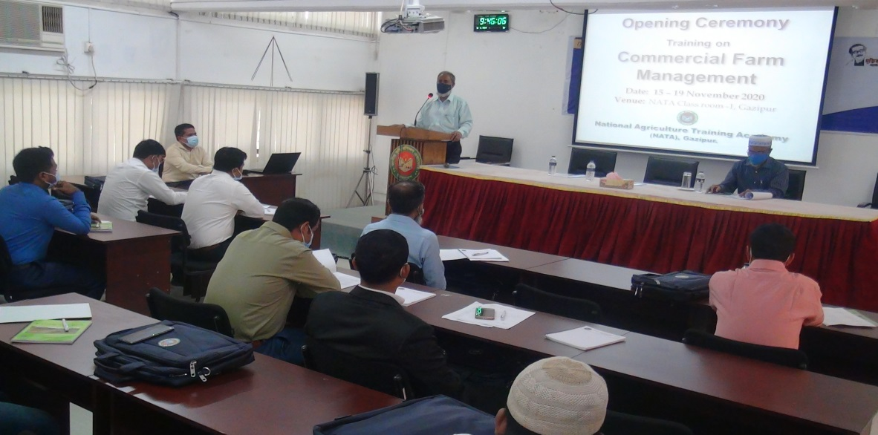
Inaugural ceremony addressed by Chief Guest, DG, NATA

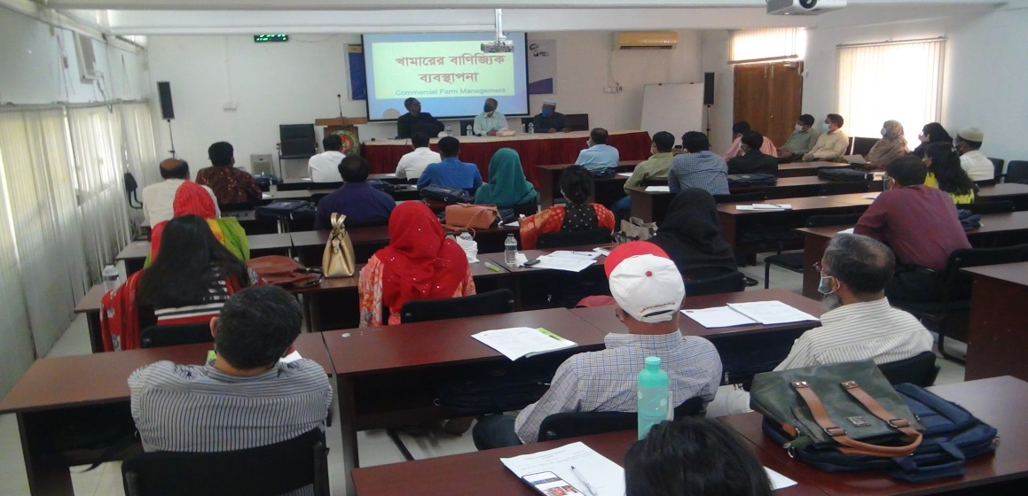

Session conducted by Professor Dr. Sadrul Amin, HSTU, Dinajpur

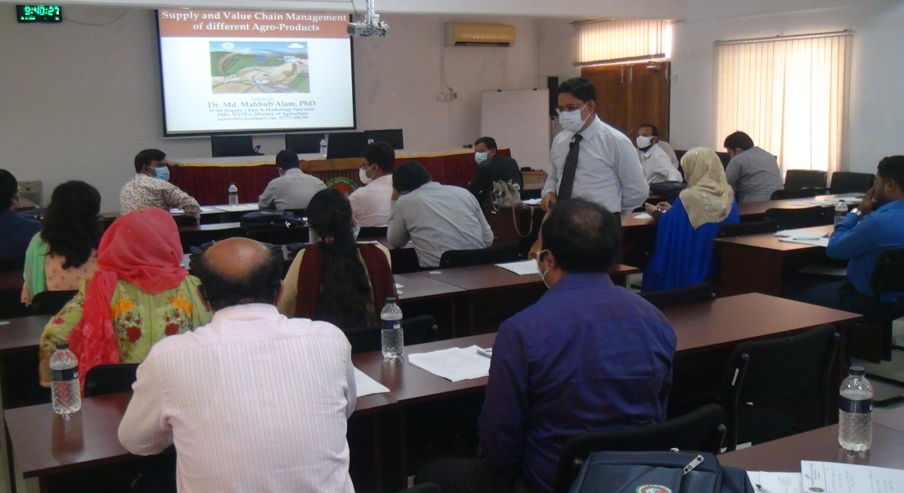
Session conducted by Dr. Dr. Md. Mahbub Alam
Producer Organization Mobil. Specialist, PMU, NATP-2, BARC

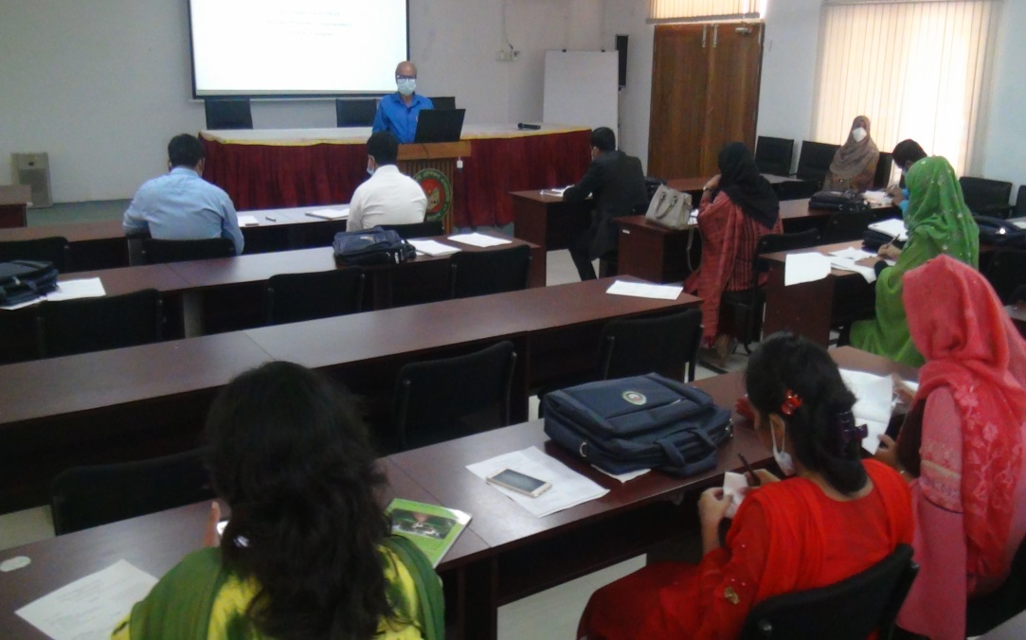
Session conducted by Dr. Abdul Awal Miah
Course co-coordinator & DD (Agronomy), NATA

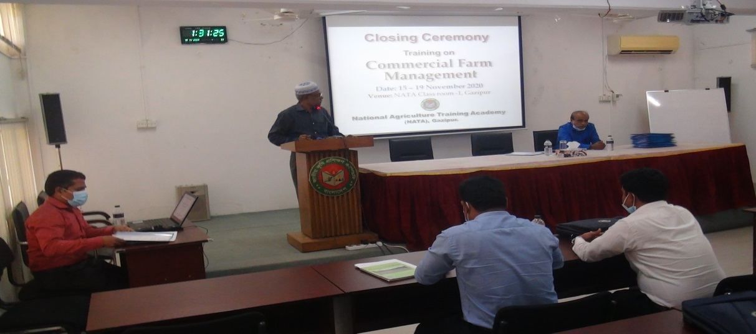
Closing ceremony addressed by Chief Guest, Coordinator
(Training Cell) & DD (Entemology) NATA

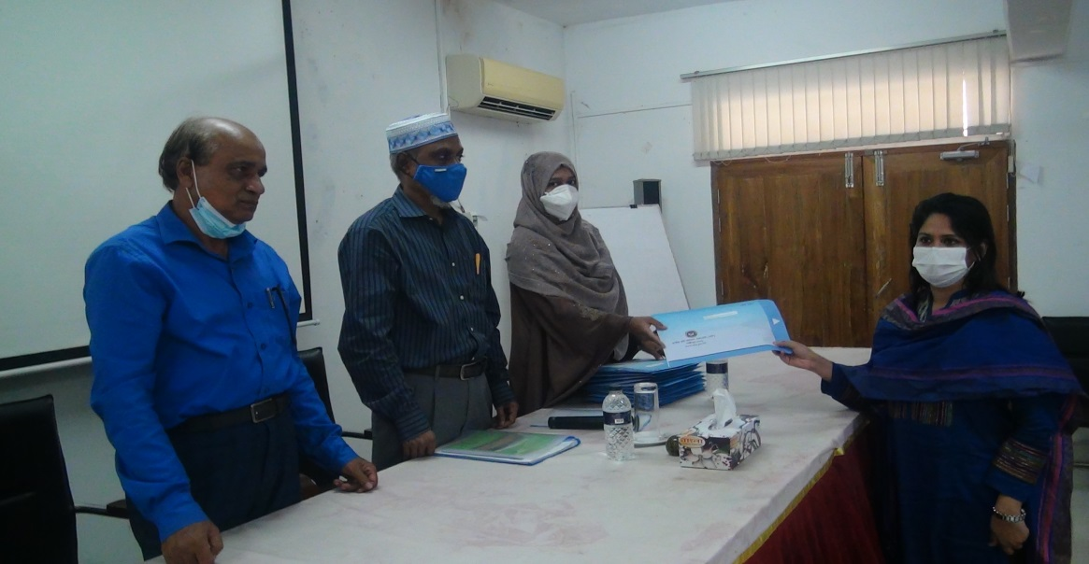
Certificate distribution among the participants

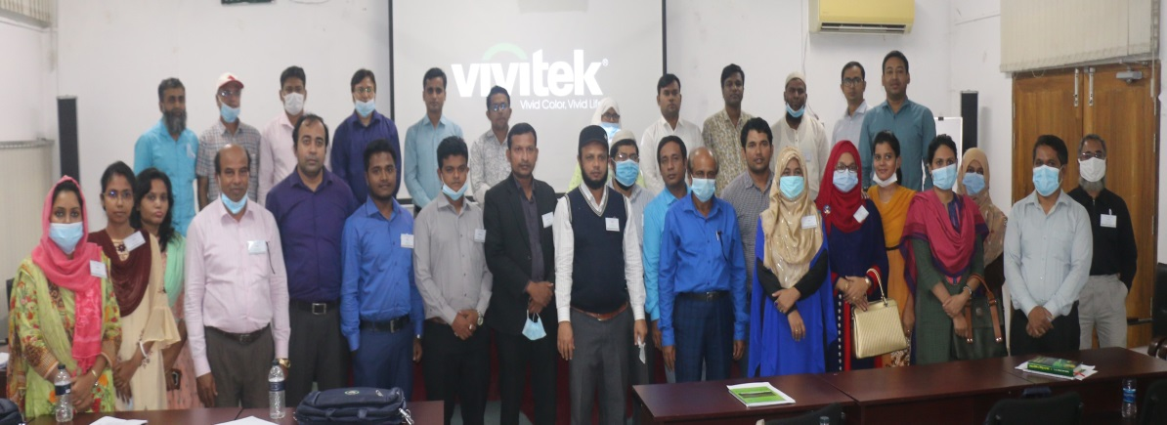
Picture of the trainees & course management team
